**Jupyter Assignments as HTML**

Go to the top bar of your Jupyter notebook:

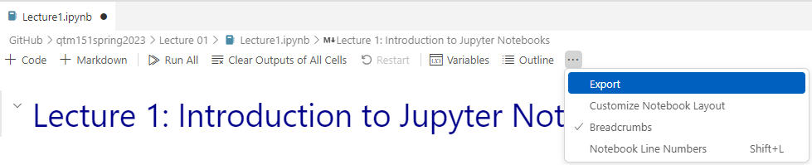

Select the option “HTML” and store it in the same folder as the assignment.

**ONLY upload the HTML file**

* This make it easier for us to grade your assignment because we can see your output directly in the browser.